**Analysis of Use Cases: Asynchronous vs Parallel Programming**

1Shreyash Bhardwaj, [shreyashbhardwaj2002@gmail.com](mailto:shreyashbhardwaj2002@gmail.com),

2Shilpa Nayak, Assistant Professor, [shilpa_cs@msrcsasc.edu.in](mailto:shilpa_cs@msrcsasc.edu.in),

M S Ramaiah College of Arts, Science and Commerce

**Abstract:**

As software systems continue to evolve, developers face the challenge of optimizing performance while ensuring responsiveness and scalability. Two prevalent approaches to addressing this challenge are asynchronous and parallel programming paradigms. This paper presents a comprehensive analysis of these approaches in various use cases, evaluating their effectiveness in achieving performance goals and managing complexities inherent in modern software systems. The analysis begins by defining asynchronous and parallel programming paradigms, highlighting their fundamental differences and common application scenarios. Subsequently, it examines use cases where each paradigm excels, such as web server applications, real-time systems, and data processing pipelines. Through a comparative study, the paper elucidates the trade-offs associated with each approach in terms of concurrency control, resource utilization, and code maintainability. Ultimately, this research paper serves as a practical guide to help programmers choose the paradigm that will work best in each scenario.

Keywords: asynchronous programming, parallel programming, performance optimization, concurrency control, use case analysis.

**Introduction:**

In the dynamic realm of software development, optimizing performance while ensuring responsiveness and scalability is paramount. Asynchronous and parallel programming paradigms have emerged as pivotal strategies for tackling this challenge, offering developers powerful tools to enhance system efficiency and manage concurrent operations effectively. This paper titled “Analysis of Use Cases: Asynchronous vs Parallel Programming” presents a comprehensive analysis of these paradigms, exploring their fundamental principles, application scenarios, and comparative advantages across various use cases.

By elucidating the trade-offs associated with concurrency control, resource utilization, and code maintainability, this research aims to equip developers with the insights needed to make informed decisions when selecting the appropriate programming paradigm for their projects. Through a systematic examination of real-world scenarios, including web server applications, real-time systems, and data processing pipelines, this paper seeks to provide practical guidance for navigating the complexities of modern software development and optimizing performance in software systems.

**Methodology:**

This methodology integrates literature review, use case selection, empirical experimentation and analysis to provide a comprehensive evaluation of asynchronous and parallel programming paradigms in various real-world scenarios. By following this methodology, I systematically investigated the effectiveness and practical implications of these paradigms, contributing valuable insights to the field of software engineering and performance optimization.

1. **Literature Review**: Conduct a thorough review of existing literature, including academic papers, books, and technical documentation, to understand the foundational concepts, principles, and best practices of asynchronous and parallel programming paradigms. Identify key use cases and case studies that demonstrate the application of these paradigms in real-world scenarios.

2. **Use Case Selection**: Identify a diverse set of use cases representing different domains and application scenarios where asynchronous and parallel programming paradigms are commonly employed. Consider factors such as system requirements, performance goals, and concurrency constraints when selecting use cases.

3. **Data Collection**: Gather relevant data and information for each selected use case, including system specifications, performance metrics, and implementation details. This may involve studying existing software systems, conducting experiments, or analysing real-world datasets to capture the performance characteristics of asynchronous and parallel implementations.

4. **Implementation and Experimentation**: Implement asynchronous and parallel versions of the selected use cases using appropriate programming languages and frameworks. Design experiments to evaluate the performance of each implementation under various conditions, such as varying workload, input size, and system resources. Measure key performance metrics, such as execution time, throughput, and resource utilization, to assess the effectiveness of each programming paradigm in meeting performance goals.

5. **Analysis and Comparison**: Analyse the experimental results to identify trends, patterns, and trade-offs associated with asynchronous and parallel programming paradigms. Compare the performance of asynchronous and parallel implementations across different use cases, considering factors such as scalability, concurrency control, and code maintainability. Interpret the findings to draw meaningful conclusions regarding the suitability of each paradigm for specific application scenarios.

**Results and Analysis:**

My experimental findings suggest that each paradigm, whether Parallel or Asynchronous, excels in distinct scenarios. Specifically, when confronted with CPU-bound operations, the Parallel Programming Paradigm consistently exhibits minimal execution times compared to the Asynchronous Programming Paradigm. This observation underscores the efficiency of parallel processing in tasks where CPU utilization is paramount. To comprehensively assess the utility of each paradigm across various scenarios, I meticulously devised programs tailored to each instance. These instances encompass a diverse range of scenarios, each meticulously crafted to highlight the strengths and weaknesses of both parallel and asynchronous programming paradigms. Through systematic experimentation and analysis, these programs serve to elucidate the optimal choice of paradigm based on the specific characteristics and requirements of each scenario.

1. **CPU Bound Operation:**

A CPU-bound operation is characterized by its heavy reliance on the processing power of the CPU (Central Processing Unit) for execution, wherein the performance is predominantly constrained by the speed and capabilities of the CPU rather than other system resources such as memory, disk I/O, or network bandwidth. To determine the most suitable paradigm for handling CPU-bound operations, two Python scripts were devised.

In the first program, two functions representing asynchronous and parallel paradigms were created, each tasked with a simple operation of inducing a one-second delay, simulating CPU-bound tasks of varying durations. The output demonstrated that in both scenarios, parallel programming outperformed asynchronous programming, indicating its superior suitability for CPU-bound tasks.

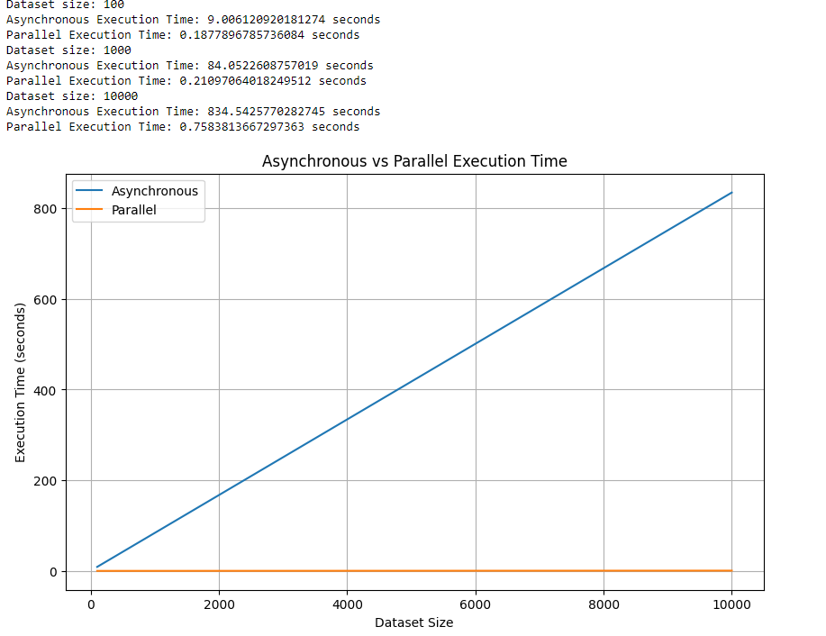

Similarly, in the second program, CPU-bound operations were simulated through the calculation of Fibonacci sequences. Again, functions representing asynchronous and parallel paradigms were devised to calculate Fibonacci sequences for varying datasets. The output revealed that parallel programming consistently exhibited faster execution times compared to its asynchronous counterpart.

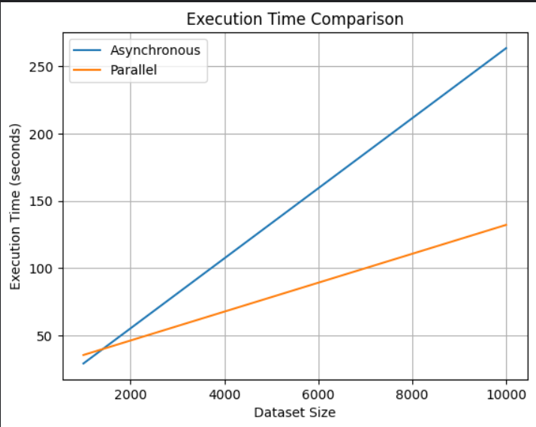

Thus, across both scenarios, parallel programming emerged as the more optimal choice for CPU-bound tasks, owing to its ability to decompose tasks into smaller, independent units of work that can be executed concurrently, thereby maximizing CPU utilization and overall performance efficiency.

1. **Data Processing**

Data processing encompasses the manipulation and transformation of raw data into actionable insights through a series of operations, including organization, sorting, filtering, aggregation, analysis, and summarization. To ascertain the most suitable paradigm for handling such operations, two discrete code implementations were devised for comparison.

In the initial program, the performance of asynchronous and parallel processing for a rudimentary data processing task was evaluated. A function was defined to execute the data processing task, which involved a simple multiplication operation. The program systematically measured the execution times for both asynchronous and parallel processing across various dataset sizes and presented the results graphically to illustrate the impact of dataset size on execution time for each processing paradigm.

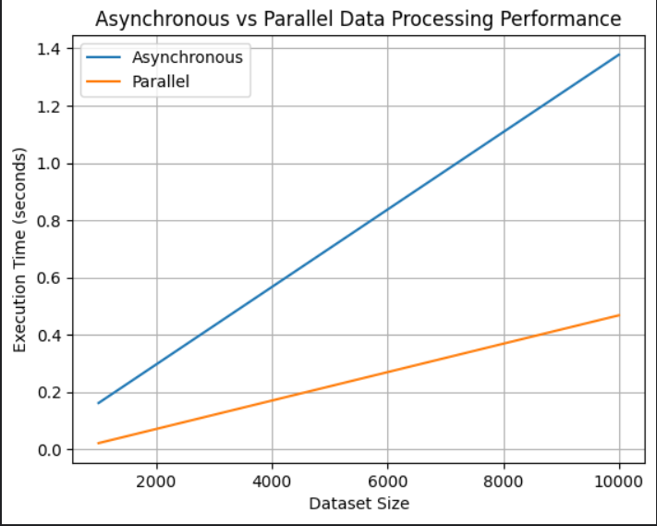

Conversely, the second program scrutinized the performance of asynchronous and parallel processing for a more complex data processing task. Functions were formulated for asynchronous and parallel processing, each tasked with calculating the square root of numbers in a dataset. The primary function iterated over diverse dataset sizes, gauged the execution times for both paradigms, and tabulated the outcomes. Subsequently, the program visualized the execution times on a graph to elucidate the performance disparity between asynchronous and parallel processing approaches.

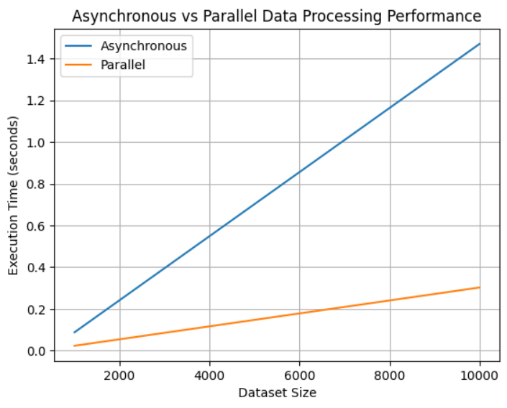

The conclusive findings indicate that, within the realm of data processing, the parallel paradigm demonstrates superiority over asynchronous processing. This recommendation stems from the empirical evidence gathered through systematic experimentation and analysis, emphasizing the pragmatic benefits of employing parallel processing for efficient data manipulation and transformation tasks.

1. **IO-Bound Operation**

An I/O-bound operation denotes a task or process that predominantly awaits input/output operations to finalize, rather than actively utilizing the CPU for computation. This performance limitation is chiefly dictated by the pace of input/output devices, encompassing disk drives, network connections, or user input/output interfaces. To discern the more suitable paradigm for handling such operations, two distinct code implementations were devised.

In the first program, the execution times of processing files asynchronously and in parallel were compared. This entailed reading the contents of a file, transforming them to uppercase, and subsequently writing the processed content to a new file. Leveraging 'concurrent.futures', the script gauged the execution duration for each approach and rendered a graphical comparison for visual interpretation.

e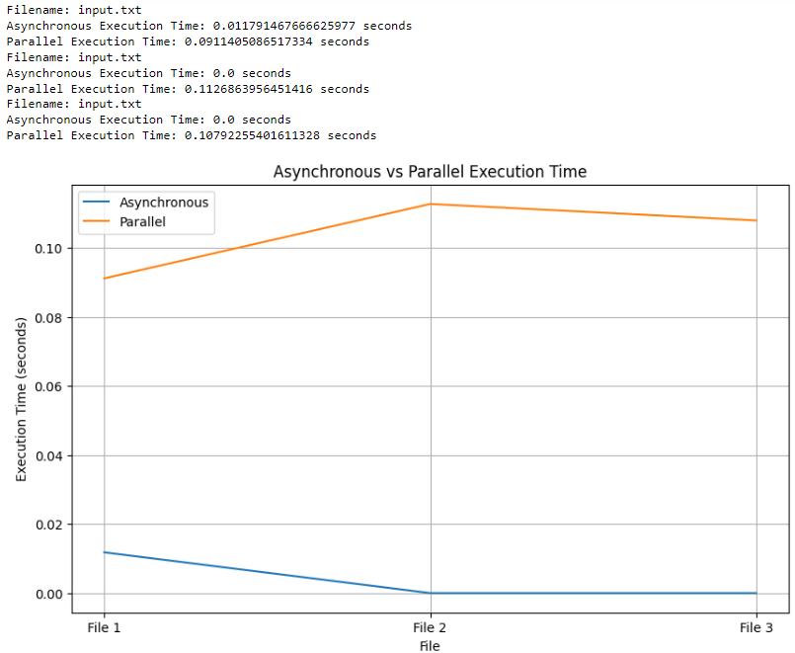

In the second program, the performance of asynchronous and parallel concurrency in retrieving images from URLs was juxtaposed. Employing `aiohttp`, images were asynchronously fetched, while `requests` and `concurrent.futures` were enlisted for parallel retrieval. Execution times for both methodologies were meticulously measured across multiple iterations, and the ensuing results were charted using `matplotlib` for comprehensive analysis.

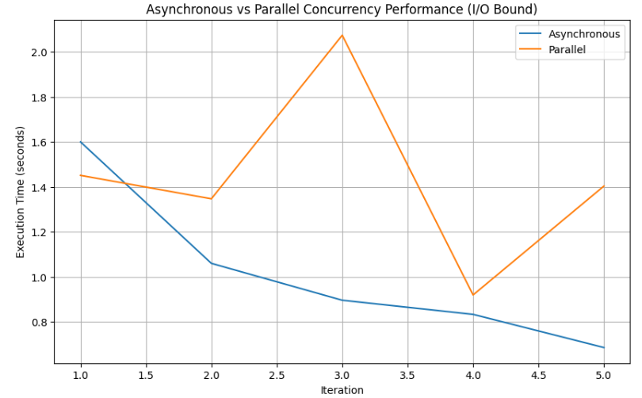

The cumulative findings unmistakably endorse the asynchronous approach over its parallel counterpart in both scenarios. This underscores the efficacy of asynchronous programming in optimizing performance for I/O-bound operations, thereby advocating for its adoption in analogous real-world contexts.

1. **Concurrency**

Concurrency refers to a system's capability to manage multiple tasks or processes concurrently, allowing them to progress independently and potentially simultaneously, thereby optimizing resource utilization and enhancing overall performance. While both asynchronous and parallel programming paradigms facilitate concurrency, the objective was to determine their relative suitability. Two programs were developed for this purpose.

In the first program, both paradigms were tasked with executing the code "(i + 1) ** 2," simulating processing tasks on large datasets. The output demonstrated the efficiency of asynchronous programming in handling concurrency.

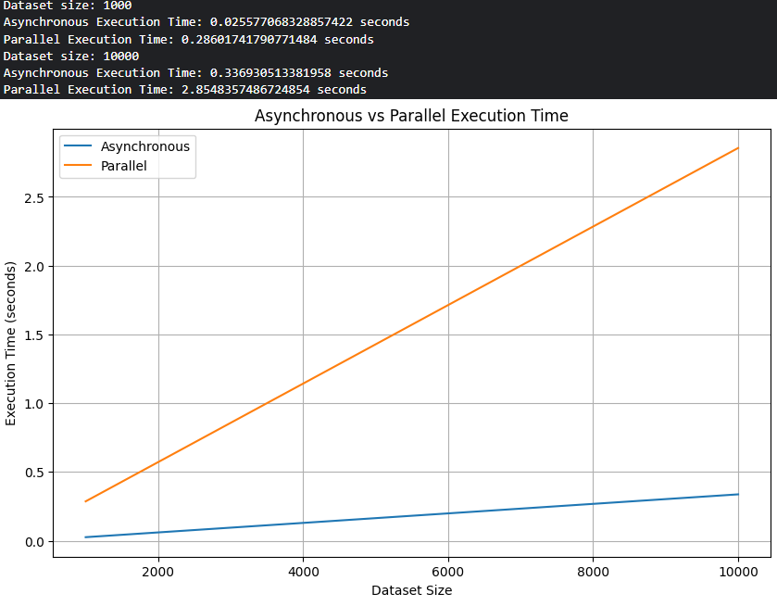

In the second program, the performance of asynchronous and parallel concurrency was compared in fetching data from URLs, visually represented through a graph. Utilizing the 'aiohttp' library for asynchronous requests and 'requests' for parallel execution, the output conclusively favored asynchronous programming for concurrency tasks.

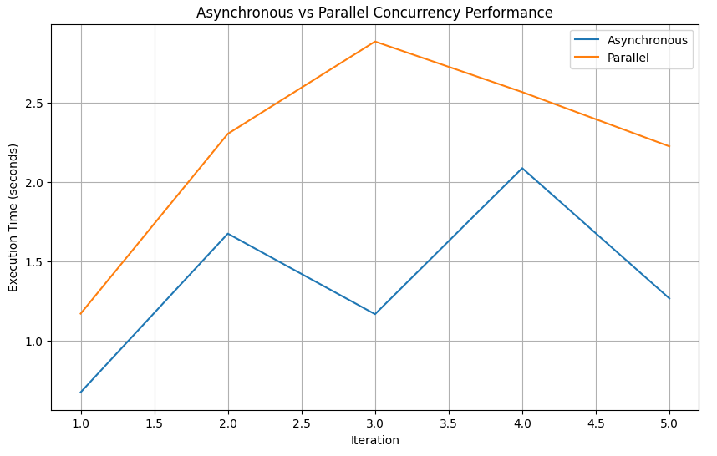

Asynchronous programming's ability to handle multiple tasks concurrently without creating a new thread for each task showcased its efficiency in resource utilization compared to parallelism. Thus, the findings suggest that asynchronous programming is better suited for concurrency-intensive tasks, offering enhanced performance and scalability in real-world applications.

**Conclusion:**

In conclusion, this research offers a comprehensive analysis of asynchronous and parallel programming paradigms across diverse use cases, highlighting their respective strengths and trade-offs in optimizing performance and managing complexities in modern software systems. By synthesizing insights from real-world scenarios and empirical experimentation, this study provides practical guidance for developers in selecting the appropriate programming paradigm based on factors such as concurrency control, resource utilization, and code maintainability. Moving forward, continued exploration of emerging technologies and methodologies will further refine our understanding of performance optimization strategies, empowering developers to design more efficient and scalable software systems that drive innovation and progress in the field of software engineering.

**References:**

1. "Choosing Between Parallel and Asynchronous Processing in Python" by Real Python - Real Python's article explores the decision-making process between parallel and asynchronous programming in Python, considering factors such as CPU-bound vs I/O-bound tasks and the nature of the workload.
2. "When to Use Asynchronous Programming in Python" by Andrei Neagoie - This YouTube video discusses the benefits and use cases of asynchronous programming in Python, particularly focusing on scenarios where it can improve performance and responsiveness.
3. "Understanding Asynchronous Programming and Its Use Cases" by Mozilla Developer Network (MDN) - MDN's guide to asynchronous programming provides insights into when and why asynchronous programming is beneficial, helping developers understand its use cases across different languages and platforms.
4. "Python Parallel Programming Cookbook" by Giancarlo Zaccone - This cookbook provides practical recipes for parallel programming in Python, covering libraries such as multiprocessing and concurrent.futures.
5. "When to Use Parallel Programming vs Asynchronous Programming" by Donatas Stonys - This blog post discusses various scenarios where parallel and asynchronous programming shine, providing examples and insights into when each approach is appropriate.
6. Online Resources:
   1. Microsoft Docs: Asynchronous programming with async and await (<https://docs.microsoft.com/en-us/dotnet/csharp/async>)
   2. Mozilla Developer Network (MDN): Asynchronous programming (<https://developer.mozilla.org/en-US/docs/Learn/JavaScript/Asynchronous>)
   3. Python documentation: Concurrent execution using asyncio (<https://docs.python.org/3/library/asyncio.html>)
   4. Real Python: Understanding Asynchronous Programming (<https://realpython.com/python-async-features/#understanding-asynchronous-programming>)
   5. Medium: An Introduction to Asynchronous Programming (<https://medium.com/velotio-perspectives/an-introduction-to-asynchronous-programming-in-python-af0189a88bbb>)
   6. GeeksforGeeks: Asyncio in Python (<https://www.geeksforgeeks.org/asyncio-in-python/>)
   7. GeeksforGeeks: Parallel Processing in python (<https://www.geeksforgeeks.org/parallel-processing-in-python/>)
   8. SitePoint: A Guide to Python Multiprocessing and Parallel Programming (<https://www.sitepoint.com/python-multiprocessing-parallel-programming/>)
   9. Udacity: What is Python Parallelization? (<https://www.udacity.com/blog/2020/04/what-is-python-parallelization.html>)
   10. Real Python: Python Concurrency & Parallel Programming (Learning Path) (https://realpython.com/learning-paths/python-concurrency-parallel-programming/)